Kamraj

BESIT

Robotic Arm

Project Report

Contents

Figure list 2

1 Inroduction 3

2 DESIGN 5

2.1.1 WE FINALISED THE EDUCATIVE 6 AXIS ROBOT ARM PROJECT 6

2.1.2 THE DIY-ROBOTICS EDUCATIVE CELL 6

2.2 MECHANICAL CORE (Body) 7

2.2.1 links 7

2.2.2 joints 12

3 FABRICATION 14

3.1 Mechanical 14

3.1.1 PROBLEMS WHILE FABRICATION 14

# Figure list

Figure 2.1 Base link 7

Figure 2.2 link 1 8

Robotic arm

# Inroduction

Robotic arm we are making is desktop size Articulated robot with a gripper which can be used to handle very small loads, with 6 (Degree of freedom) DOF. The inspiration for making this robot is from Iron Man movie this is miniature robot arm

|  |  |
| --- | --- |
|  |  |

Now day robots are used for all kinds of work form cleaning to high precision cutting in industries as well as in small scale industries even for cooking

|  |  |
| --- | --- |
|  |  |

Robotic arm is a mechanical manipulator designed to perform many different tasks and capable of repeating, using variable programming. to perform its assigned tasks, the robot can move parts, objects, tools, and special devices by means of programmed motions and points.

Its main function is to move from point to point, as instructed by the controller

In manufacturing industry and nuclear industry, a large fraction of the **work is repetitive** and judicious application of automation will most certainly result in optimum utilization of machine and manpower. A pneumatic `Pick and Place' Robot has been developed to achieve automation in applications where great sophistication is not needed and simple tasks like picking up of small parts at one location and placing them at another location can be done with great ease

# DESIGN

We have found 4 interesting designs on web

1. A4
2. Thor
3. Educative 6 Axis Robot Arm
4. BCN3D/BCN3D-Moveo

|  |  |
| --- | --- |
| * 1.A4 | * 2.Thor |
| * 3.Educative 6 Axis Robot Arm | * 4.BCN3D/BCN3D-Moveo |

### WE FINALISED THE EDUCATIVE 6 AXIS ROBOT ARM PROJECT

BASED ON

* All the Materials very accessible
* Can be built with in Rs:30,000 easily
* less complex in design than other 3 projects
* less number of parts than other 3 projects
* Small in size
* prebuild control software ready to use if programming fails
* No need of any specialised motors like in A4 project

### THE DIY-ROBOTICS EDUCATIVE CELL

The DIY-Robotics educative cell is a platform that includes a 6-axis robotic arm, with an electronic control circuit and a programming software prebuild.

This platform is an introduction to the world of industrial robotics. Through this project, DIY-Robotics wishes to offer an affordable but quality solution to all those who would like to learn more about this fascinating field. This project is an excellent opportunity to develop various knowledge and skills in the fields of mechanics, electrical as well as computer science. With the DIY Robotics educative cell, robotics is within everyone's reach has of now explained above this is fabulous project we have taken only the mechanical core of the project and modifying the electrical and using ROS software for control.

## MECHANICAL CORE (Body)

Robotic mechanism which consists of a series of segments called links which are joined together (rotating or sliding relative to one another) for the purpose of grasping and/or moving objects (pieces or tools)

### links

The static material, which connects the joints of an arm together. Thereby a kinematical chain is formed.

E.g., In a human body, the links are the bones

All links are designed to 3D-Print

#### Base Link (LINK-0)

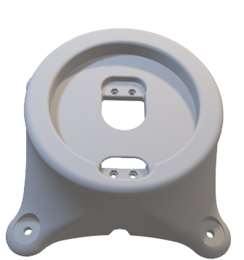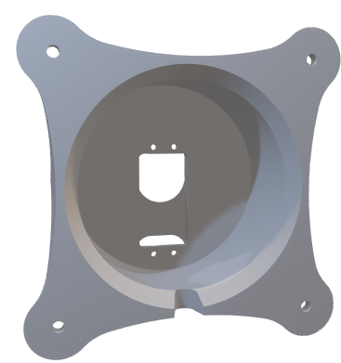The stationary base structure of a robot arm that supports the first joint

Figure 2.1 Base link

A cylindrical cup like structure having flange with 4 holes at bottom and circular slot on top to insert link-1[2.2.1.2] with pockets and cut-outs for mounting motor

#### link-1

Figure 2.2 link 1

A U-shape like structure having cylindrical guide to fit on circular slot of Base-link [2.2.1.1]. At one end circular cut-out to guide the link-2 [2.2.1.3] and on other end place to fit the motor.

#### link-2

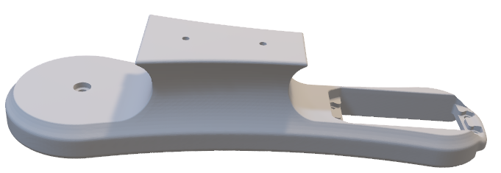

#### link-3

#### link-4

#### link-5

### joints

# FABRICATION

## Mechanical

### PROBLEMS WHILE FABRICATION

#### PRINTED PARTS IS NOT GOOD HAS WE THOUGHT

##### DESCRIPTION: